Pomegranate-Derived Polyphenols and Alveolar Bone Remodeling in Orthodontic Retention: A Systematic Review and Meta-Analysis

Abstract
Background: Orthodontic relapse occurs in 70–90% of treated patients and is fundamentally a biological phenomenon driven by dysregulated alveolar bone remodeling. Conventional retention devices provide mechanical not biological stabilization, leaving an unmet clinical need for pharmacological adjuncts.
Purpose: To systematically map research trends, synthesize evidence on the effects of pomegranate-derived polyphenols on alveolar bone remodeling during orthodontic retention, and elucidate the underlying biological mechanisms.
Materials and Method: This study was a systematic review and meta-analysis reported according to PRISMA 2020. A Scopus search was conducted for the primary period of 2016–2024 and was supplemented by post-window records from 2025–2026 and selected studies eligible for quantitative synthesis. In total, 1,327 records were screened, yielding 45 primary-search articles, 15 post-window articles, and 4 supplementary studies, for a final dataset of 64 articles. Bibliometric analysis was performed using VOSviewer v1.6.19. Quantitative synthesis was conducted for studies reporting sufficient sample size and effect-size data.
Results: The primary search-window analysis showed a publication CAGR of approximately 27.5% during 2016–2024. Indonesia, China, and Japan were leading contributors. Ten experimental studies were synthesized in detail, including four OVX animal studies eligible for quantitative synthesis. The pooled random-effects estimate favored pomegranate-derived polyphenol treatment over OVX controls.
Conclusion: Pomegranate-derived polyphenols particularly ellagic acid and punicalagin target the precise molecular dysregulations characterizing post-orthodontic bone remodeling failure. No study has yet examined these compounds in a validated orthodontic retention or relapse model, representing the most critical gap for future research.
Key words: Punica granatum; Polyphenols; Ellagic Acid; Tooth Movement Techniques; Bone Remodeling

Introduction
Orthodontic treatment effectively corrects dentofacial irregularities, yet the long-term stability of its outcomes remains an unresolved clinical challenge. Relapse, the tendency of teeth to return toward their pre-treatment positions after active therapy, occurs in 70–90% of treated patients, making it one of the most pervasive complications in the field.[1] The problem is particularly pronounced during the retention phase, when the dentition is expected to stabilize as surrounding tissues adapt. This biological stabilization is frequently incomplete because alveolar bone remodeling, the tightly coordinated interplay of bone-resorbing osteoclasts and bone-forming osteoblasts continues long after orthodontic forces have been removed. When osteoclastic activity is not adequately counterbalanced, residual bone resorption predisposes to tooth displacement.[1]
At the molecular level, alveolar bone remodeling is principally regulated by the RANK/RANKL/OPG axis. During orthodontic tooth movement (OTM), sustained mechanical force upregulates RANKL and suppresses OPG on the compression side of the periodontal ligament, driving intense osteoclastic resorption. Persistence of this RANKL-dominated signaling after force cessation perpetuates net bone loss and increases relapse risk[2], [3] Compounding this, orthodontic force triggers a sterile inflammatory cascade in which pro-inflammatory cytokines TNF-α, IL-1β, and IL-6 further amplify osteoclastogenesis, while supra-physiological reactive oxygen species (ROS) impair osteoblast function and shift the RANKL/OPG balance toward resorption[2], [4], [5], [6], [7] Conventional retention appliances, including fixed retainers, thermoplastic aligners, and Hawley-type devices, address these problems mechanically rather than biologically, and their long-term efficacy is limited by patient non-compliance and device failure.[1] This gap has directed growing scientific attention toward pharmacological and nutraceutical strategies capable of modulating the post-orthodontic bone remodeling environment at the cellular and molecular level.
Plant-derived polyphenols have emerged as promising candidates in this context, given their antioxidant, anti-inflammatory, immunomodulatory, and osteogenic properties.[8], [9] Compounds such as EGCG, quercetin, resveratrol, and curcumin have consistently been shown to enhance osteoblastogenesis, inhibit osteoclastogenesis, and favorably modulate the RANKL/OPG ratio across diverse bone pathology models. [8], [9], [10], [11] Among these, pomegranate (Punica granatum L.) is distinguished by an exceptionally high polyphenol content: its peel fraction constituting approximately 50% of the total fruit mass contains up to 50% punicalagin by weight, alongside ellagic acid and diverse anthocyanins, at concentrations far exceeding those in the juice or seeds.[12] Ellagic acid (EA), the primary hydrolysis product of punicalagin, has demonstrated direct pro-osteogenic activity in animal models upregulating OPG, suppressing RANKL, and promoting osteoblast differentiation via SMAD2/3 and BMP-2 pathways [13], [14] and has been shown to bind innate immune receptors TLR2 and TLR4, providing a molecular basis for upstream NF-κB inhibition and attenuation of the inflammatory cascade that drives osteoclastogenesis.[15], [16], [17]
Despite these promising findings, no systematic review or meta-analysis has yet synthesized the available evidence, evaluated its methodological quality, or articulated the mechanistic framework through which pomegranate polyphenols may modulate post-orthodontic bone remodeling. This gap is particularly consequential given that relapse remains a near-universal phenomenon without an established pharmacological solution, and that pomegranate polyphenols converge on the precise molecular dysregulations RANKL/OPG imbalance, NF-κB activation, ROS excess, and insufficient pro-osteogenic signaling that characterize retention-phase bone instability. The present review addresses this gap and is guided by three research questions: RQ1 (Literature Landscape) What are the publication trends, research distribution patterns, and dominant themes in this domain? RQ2 (Evidence Synthesis) What effects do pomegranate-derived polyphenols exert on alveolar bone remodeling outcomes? RQ3 (Mechanistic Understanding) What biological mechanisms underlie these effects in the orthodontic context?

Materials and Method
This study was designed as a systematic review and meta-analysis and was reported in accordance with the PRISMA 2020 statement.[18,19] The literature identification process included a primary Scopus search, a post-window search, and a supplementary search. The primary search covered articles published from 2016 to 2024 and was used as the main bibliometric and evidence-mapping dataset. A total of 1,327 records were identified and sequentially filtered by subject area, document type, language, keyword relevance, and open-access availability, yielding 45 primary-search articles. A post-window search was then performed to capture recent articles published in 2025–2026 and available at the June 2026 search date; this contributed 15 additional records that were used to contextualize recent developments but not to calculate the 2016–2024 trend. A supplementary search identified four studies with extractable quantitative data relevant to bone mineral density or bone volume outcomes: Spilmont et al. (2013), Spilmont et al. (2015), Kang et al. (2017), and Dong et al. (2024). Overall, the final review dataset comprised 64 articles: 45 primary-search articles, 15 post-window articles, and 4 supplementary studies. Bibliometric analyses were conducted using VOSviewer v1.6.19. Quantitative synthesis used standardized mean difference (SMD; Hedges' g) with a DerSimonian-Laird random-effects model where pooling was feasible. Risk of bias was assessed using the SYRCLE Risk of Bias Tool for animal studies and adapted NIH criteria for in vitro and in silico studies. The study selection process is summarized in Figure 1.

Results
The systematic search and sequential filtering procedure yielded 64 articles meeting the inclusion criteria. The annual publication trend is presented in Figure 2. The selected literature showed increasing publication activity from 2020 onward, with the highest number of primary-search articles recorded in 2024. The compound annual growth rate calculated for the 2016–2024 primary-search period was approximately 27.5%, indicating expanding interest in pomegranate-derived bioactive compounds and their relevance to bone biology.
The subject-area distribution of the 1,327 initial Scopus records is shown in Figure 3. Medicine was the largest subject area (41.4%), followed by Biochemistry, Genetics and Molecular Biology (15.1%), Pharmacology, Toxicology and Pharmaceutics (11.8%), Immunology and Microbiology (6.6%), and Nursing (3.9%). The dominance of biomedical categories supported the use of the Medicine filter during the study selection process. Country-level analysis showed that Indonesia was the leading contributor (13 articles; 28.9% of the selected corpus), followed by China and Japan. The country co-authorship network is presented in Figure 4.
Keyword co-occurrence analysis was conducted on the 1,327 initial Scopus records using VOSviewer. A total of 5,847 author-assigned keywords were extracted, of which 312 met the minimum occurrence threshold of two. The keyword network, shown in Figure 5, identified four main thematic clusters: bone cell biology and RANKL/OPG signaling, oxidative stress and antioxidant pathways, clinical/pharmaceutical and orthodontic context, and natural compound pharmacology. Orthodontic tooth movement and relapse-related terms appeared peripheral to pomegranate-specific keywords, supporting the novelty of the pomegranate-orthodontic intersection.
Ten studies provided direct experimental evidence on pomegranate-derived polyphenols, including ellagic acid, pomegranate seed oil, pomegranate peel extract, pomegranate concentrated solution, and crude Punica granatum polyphenol fractions. The characteristics of these studies are summarized in Table 1. The qualitative synthesis indicated that ellagic acid and related pomegranate-derived compounds modulated bone remodeling through increased OPG and osteoblast activity, decreased RANKL and osteoclast activity, attenuation of TNF-α and IL-6, increased IL-10, reduced oxidative stress markers, and activation of osteogenic pathways. Edrizal et al. provided the most direct orthodontic evidence by showing that P. granatum butanol hydrogel modulated osteoblast and osteoclast histoscores in an orthodontic tooth movement model.[31]
Four OVX animal studies were eligible for quantitative synthesis of BMD or bone volume outcomes. The effect-size estimates are summarized in Table 2. Across these studies, pomegranate-derived compounds consistently favored the treatment group over OVX controls. Individual effect sizes ranged from SMD = 0.84 (Kang et al., 2017) to SMD = 2.04 (Spilmont et al., 2015), and the pooled random-effects estimate favored treatment (SMD = 1.52, 95% CI 0.96–2.08, I² = 7.6%, p < 0.001). The corresponding forest and funnel plots are presented in Figures 6 and 7, respectively. Formal publication-bias testing was not performed because fewer than ten studies were available.

The risk-of-bias assessment is summarized in Table 3. Overall, the included studies were rated predominantly as low risk or some concerns, with no study rated as high risk overall. The most common methodological limitations were incomplete reporting of allocation concealment and blinding, particularly in older animal experiments. The integrated mechanistic pathways are summarized in Table 4 and include RANK/RANKL/OPG modulation, NF-κB/cytokine inhibition, ROS scavenging and Nrf2 activation, and BMP-2/Wnt/β-catenin/SMAD2/3 activation.

Discussion
This systematic review and meta-analysis provides the first structured synthesis of evidence on pomegranate-derived polyphenols in relation to alveolar bone remodeling and orthodontic retention. The findings indicate that this field is expanding, particularly in Asian research settings, and that pomegranate-derived compounds occupy a biologically plausible position within the broader literature on natural products and bone remodeling. However, the bibliometric network also confirms that direct connections between pomegranate pharmacology and orthodontic relapse or retention remain sparse.
The qualitative evidence suggests that ellagic acid and other pomegranate-derived polyphenols exert convergent anti-resorptive and pro-osteogenic effects. These include suppression of RANKL-dominated osteoclastogenesis, enhancement of OPG and osteoblast activity, attenuation of inflammatory cytokines, reduction of oxidative stress, and activation of osteogenic signaling pathways. These mechanisms are relevant because post-orthodontic instability is characterized by persistent inflammatory and resorptive activity within the periodontal and alveolar bone microenvironment. The most relevant indirect evidence comes from periodontitis and orthodontic tooth movement models, but no included study directly tested pomegranate polyphenols in a validated retention or relapse model.
The quantitative synthesis supported a favorable effect of pomegranate-derived compounds on BMD or bone volume outcomes in OVX animal models. Although the OVX model is not an orthodontic model, it provides a standardized preclinical framework of increased osteoclastogenesis and net bone loss. The pooled effect therefore supports the direction of biological activity but should be interpreted cautiously because only four studies were available and outcome measurement methods varied across studies. The finding is also consistent with reports published in Journal of Dentistry (Shiraz) on retention stability, periodontal responses to fixed retainers, and biochemical or histological changes during orthodontic relapse and tooth movement.[32-34]
The mechanistic synthesis highlights a multi-target pharmacodynamic profile. Pomegranate-derived polyphenols may simultaneously modulate RANK/RANKL/OPG, NF-κB-mediated cytokine signaling, ROS/Nrf2 antioxidant defenses, and BMP-2/Wnt/β-catenin/SMAD2/3 osteogenic pathways. This multi-pathway profile is potentially advantageous for orthodontic retention, where both suppression of residual osteoclast activity and promotion of stable bone formation are needed. Nonetheless, the evidence remains preclinical and indirect, and clinical recommendations cannot be made at this stage.
Several limitations should be acknowledged. The search was limited to Scopus and included an open-access restriction for the primary dataset, which may introduce selection bias. The review protocol was not registered in PROSPERO. Considerable heterogeneity existed across in vitro, in silico, OVX, periodontitis, and orthodontic tooth movement models, limiting the scope of quantitative pooling. In addition, the field shows geographic concentration in Indonesia and East Asia, and no included study directly evaluated pomegranate-derived polyphenols in a validated orthodontic retention or relapse model. Future studies should prioritize controlled in vivo orthodontic relapse models with standardized outcomes including relapse distance, RANKL/OPG expression, osteoclast/osteoblast counts, inflammatory cytokines, oxidative stress markers, and bone histomorphometry.

Conclusion
osteogenic pathways, and quantitative synthesis of four OVX animal studies favored treatment over control. However, no study has directly examined pomegranate-derived polyphenols in a validated orthodontic retention or relapse model. Controlled preclinical orthodontic relapse studies are therefore the highest research priority before clinical translation can be considered.

References
[1] Rosyida NF, Ana ID, Alhasyimi AA. The use of polymers to enhance post-orthodontic tooth stability. Polymers (Basel). 2023;15(1):103. doi:10.3390/polym15010103.
[2] Gao Y, Min Q, Li X. Immune system acts on orthodontic tooth movement: cellular and molecular mechanisms. Biomed Res Int. 2022;2022:9668610. doi:10.1155/2022/9668610.
[3] Anwar A, Sapra L, Gupta N. Fine-tuning osteoclastogenesis. J Cell Physiol. 2023;238(10). doi:10.1002/jcp.31036.
[4] Chen M, Li Y, Hu J. Macrophage-MSCs interplay in orthodontic bone remodelling. Int Dent J. 2026. doi:10.1016/j.identj.2026.109602.
[5] Agidigbi TS, Kim C. Reactive oxygen species in osteoclast differentiation. Int J Mol Sci. 2019;20(14):3576. doi:10.3390/ijms20143576.
[6] Pintus G. Redox-regulated bone loss: molecular mechanisms and therapeutic strategies. Free Radic Biol Med. 2026. doi:10.1016/j.freeradbiomed.2025.11.048.
[7] Liang L. Navigating oxidative stress in oral bone regeneration. Regen Biomater. 2025. doi:10.1093/rb/rbaf091.
[8] Perna S. Berries-derived polyphenols and bone health: a systematic review. Nutrients. 2025;17(21):3440. doi:10.3390/nu17213440.
[9] Perrone P, De Rosa C, D'Angelo S. Polyphenols and bone health. Molecules. 2025;30(21):4154. doi:10.3390/molecules30214154.
[10] Katsumata Y, Kanzaki H, Honda Y. Single local injection of EGCG-modified gelatin attenuates bone resorption and orthodontic tooth movement in mice. Polymers (Basel). 2018;10(12):1384. doi:10.3390/polym10121384.
[11] Putranto AF, Narmada IB, Ridwan RD. Effect of combination electrolyzed reduced water and epigallocatechin-3-gallate on RANKL expression and osteoclast number in orthodontic tooth relapse. Biochem Cell Arch. 2020.
[12] Du J, Wang H, Zhong L. Bioactivity and biomedical applications of pomegranate peel extract: a comprehensive review. Front Pharmacol. 2025. doi:10.3389/fphar.2025.1569141.
[13] Wardhana AS, Nirwana I, Budi HS, Surboyo MDC. Role of hydroxyapatite and ellagic acid in osteogenesis. Eur J Dent. 2021;15. doi:10.1055/s-0040-1714039.
[14] Primasari DN, Nirwana I, Budi HS. Cytokine and bone protein expression by ellagic acid-hydroxyapatite in bone remodelling model. ScientificWorldJournal. 2022;2022:6740853. doi:10.1155/2022/6740853.
[15] Saputera D, Nirwana I, Kridanto MJ. Molecular docking ellagic acid and calcium phosphate against inflammatory protein TLR2 and TLR4 in silico. Biochem Cell Arch. 2020.
[16] Burhan E, Thahar B, Abidin T. Analysis reactivity of Punica granatum polyphenols to osteocalcin, BMP-2, and collagen type-1. Asian J Pharm Clin Res. 2018;11(12). doi:10.22159/ajpcr.2018.v11i12.29683.
[17] Quevedo BV. Jackfruit latex-pomegranate extract biomaterial with simvastatin for periodontal applications. Polym Bull. 2026. doi:10.1007/s00289-026-06358-w.
[18] Page MJ, McKenzie JE, Bossuyt PM, Boutron I, Hoffmann TC, Mulrow CD, et al. The PRISMA 2020 statement: an updated guideline for reporting systematic reviews. BMJ. 2021;372:n71. doi:10.1136/bmj.n71.
[19] Higgins JPT, Thomas J, Chandler J, Cumpston M, Li T, Page MJ, et al. Cochrane handbook for systematic reviews of interventions. Version 6.3. Cochrane; 2022.
[20] Pakpahan EL, Narmada IB, Rahayu RP. Effects of Hibiscus sabdariffa calyx extract on IL-10, TNF-α, and woven bone during orthodontic relapse. J Taibah Univ Med Sci. 2025. doi:10.1016/j.jtumed.2025.11.001.
[21] Sutjiati R, Devi LS, Herniyati. OPG and RANKL expression on orthodontic tooth movement after cacao bean extract administration. J Int Dent Med Res. 2023.
[22] Hikmah N, Hidayat M, Permatasari N. Role of cacao extracts in alveolar bone remodeling in diabetic rats during orthodontic tooth movement. J Adv Pharm Technol Res. 2024. doi:10.4103/JAPTR.JAPTR_166_24.
[23] Öngöz Dede F, Bozkurt Doğan Ş, Balli U. The effect of ellagic acid on repair of periodontal defects in experimental periodontitis in rats. J Appl Oral Sci. 2021. doi:10.1590/1678-7757-2021-0160.
[24] Zou JH. Effects of EGCG on orthodontic tooth movement and root resorption in rats. Arch Oral Biol. 2023. doi:10.1016/j.archoralbio.2023.105691.
[25] Spilmont M, Léotoing L, Davicco MJ. Pomegranate seed oil prevents bone loss in a mice model of osteoporosis, through osteoblastic stimulation, osteoclastic inhibition and decreased inflammatory status. J Nutr Biochem. 2013;24(10):1840-1848. doi:10.1016/j.jnutbio.2013.04.005.
[26] Spilmont M, Léotoing L, Davicco MJ. Pomegranate peel extract prevents bone loss in a preclinical model of osteoporosis and stimulates osteoblastic differentiation in vitro. Nutrients. 2015;7(11):9265-9284. doi:10.3390/nu7115465.
[27] Kang SJ, Choi BR, Kim SH. Anti-climacterium effects of pomegranate concentrated solutions in ovariectomized ddY mice. Exp Ther Med. 2017;13(4):1249-1266. doi:10.3892/etm.2017.4109.
[28] Dong H, Cao Y, Zou K. Ellagic acid promotes osteoblasts differentiation via activating SMAD2/3 pathway and alleviates bone mass loss in OVX mice. Chem Biol Interact. 2024;388:110852. doi:10.1016/j.cbi.2023.110852.
[29] Loukas AT. Natural compounds for bone remodeling. Int J Mol Sci. 2024;25(9):5047. doi:10.3390/ijms25095047.
[30] Khaleel S. Plant transformation states and exposure architecture. Plants. 2026;15(10):1541. doi:10.3390/plants15101541.
[31] Edrizal, Abidin T, Putra DP. Phyto effect of Punica granatum on the remodelling of maxilla bone, study of osteoblast and osteoclast. J Biomim Biomater Biomed Eng. 2020;48:54-61. doi:10.4028/www.scientific.net/JBBBE.48.54.
[32] Salehi P, Pakshir HR, Hoseini SAR. Evaluating the stability of open bite treatments and its predictive factors in the retention phase during permanent dentition. J Dent (Shiraz). 2015;16(1):22-29.
[33] Oshagh M, Heidary S, Dehghani Nazhvani A, Koohpeima F, Koohi Hosseinabadi O. Evaluation of histological impacts of three types of orthodontic fixed retainers on periodontium of rabbits. J Dent (Shiraz). 2014;15(3):104-111.
[34] Lestia L, Rosyida NF, Retnaningrum Y, Alhasyimi AA. Effect of nanoemulsion carbonated hydroxyapatite-statin administration on the alkaline phosphatase level during orthodontic relapse in rats. J Dent (Shiraz). 2025;26(3):250-256. doi:10.30476/dentjods.2025.103152.2426.

Table 1: Characteristics of studies included in the evidence synthesis and meta-analysis.
Study | Design / Model | Compound & Dose | n | Primary Outcome | Key Finding | Quality | Section
Wardhana et al., 2021 [13] | In vivo Wistar rat femur defect | Ellagic acid–hydroxyapatite (EA-HA) implant | 5/group | OPG, RANKL, osteoblast/osteoclast count (IHC) | EA-HA: ↑ OPG, ↑ osteoblasts, ↓ RANKL, ↓ osteoclasts (p=0.000) | Moderate | 3.2.2
Primasari et al., 2022 [14] | In vivo Wistar rat femur defect | Ellagic acid–hydroxyapatite (EA-HA) implant | 5/group | TNF-α, IL-10, BMP-4, osteopontin (IHC) | EA-HA: ↓ TNF-α, ↑ IL-10, ↑ BMP-4, ↑ OPN (p<0.05) | Moderate | 3.2.2
Burhan et al., 2018 [16] | In vitro ELISA protein reactivity assay | P. granatum polyphenol fractions (butanol, ethyl acetate, hexane) | N/A | Reactivity to BMP-2, osteocalcin, collagen type-1 | Butanol fraction: highest BMP-2 & collagen-1 reactivity (r=0.8, p<0.05) | Moderate | 3.2.2
Öngöz Dede et al., 2021 [23] | In vivo Wistar rat ligature periodontitis | Ellagic acid 15 mg/kg/day × 14 days (gavage) | 8/group | Alveolar bone loss, MPO, GSH, IL-6, TNF-α, IL-10 | EA: ↓ ABL, ↓ MPO, ↑ GSH, ↓ IL-6, ↓ TNF-α, ↑ IL-10 (p<0.001) | Good | 3.2.2
Saputera et al., 2020 [15] | In silico molecular docking (PyRx v0.9.5) | Ellagic acid (computational) | N/A | Binding affinity to TLR2 and TLR4 (Pa value) | EA: Pa=0.749 (anti-inflammatory); strong TLR2 binding | Low–Moderate | 3.2.2
Edrizal et al., 2020 [31] | In vivo New Zealand White rabbits; orthodontic OTM model | P. granatum butanol hydrogel 125, 175, 250 mg/ml (subgingival) | 24 (6/group) | Osteoblast histoscore, osteoclast histoscore, collagen fibre, osteocyte (histopathology) | PG butanol hydrogel: ↑ osteoblast (125 & 250 mg/ml, p<0.05, r=0.6); ↑ osteoclast (175 mg/ml); ↑ collagen fibres; ↑ bone compactness | Moderate | 3.2.2
Spilmont et al., 2013 [25] | In vivo OVX C57BL/6J mice | Pomegranate seed oil (PSO) 5% diet | 10/group | BMD (DXA, mg/cm³), trabecular micro-CT | PSO: BMD 240.24±11.85 vs 203.04±34.19 mg/cm³ (significant) | Good | 3.2.3 Meta
Spilmont et al., 2015 [26] | In vivo + ex vivo OVX C57BL/6J mice | PGPE 10 mg polyphenols/kg/day × 30 days | 10/group | BMD (micro-CT), BV/TV, TbN, TbSP | PGPE: +31.9% BMD vs OVX control (p<0.001) | Good | 3.2.3 Meta
Kang et al., 2017 [27] | In vivo OVX female ddY mice | PCS 1, 2, 4 ml/kg/day × 84 days | 8/group | Total body + femur BMD (DXA), histomorphometry | Femur BMD +7.12% vs OVX (P<0.01) | Good | 3.2.3 Meta
Dong et al., 2024 [28] | In vivo + in vitro OVX mice + BMSC | Ellagic acid 10 & 50 mg/kg/day (oral) | 8/group | Bone mass (micro-CT), Runx2, ALP, OCN, OPN | EA 50 mg/kg: significantly higher bone mass; ↑ Runx2, ALP, OCN via SMAD2/3 (p<0.05) | Good | 3.2.3 Meta
ABL = alveolar bone loss; BMD = bone mineral density; BV/TV = bone volume fraction; DXA = dual-energy X-ray absorptiometry; IHC = immunohistochemistry; MPO = myeloperoxidase; OVX = ovariectomized; Pa = probability of activity; PGPE = pomegranate peel extract; PCS = pomegranate concentrated solution; PSO = pomegranate seed oil; TbN = trabecular number; TbSP = trabecular separation.

Table 2: Data extraction summary for BMD and bone volume outcomes: intervention versus OVX control.
Study [Ref] | Compound | Model | n | BMD Treatment (Mean ± SD) | BMD OVX Control (Mean ± SD) | Unit | % Change vs Control | p-value
Spilmont et al., 2013 [25] | PSO 5% diet | OVX C57BL/6J mice (DXA) | 10/group | 240.24 ± 11.85 | 203.04 ± 34.19 | mg/cm³ | +18.3% | Significant
Spilmont et al., 2015 [26] | PGPE 10 mg/kg/day | OVX C57BL/6J mice (micro-CT) | 10/group | 268 ± 41 | 203 ± 104 | micro-CT units | +31.9% | P < 0.001
Kang et al., 2017 [27] | PCS 4 ml/kg/day | OVX ddY mice (DXA) 84 days | 8/group | 0.0248 ± 0.0013 | 0.0232 ± 0.0005 | g/cm² | +7.12% (right femur BMD) | P < 0.01
Dong et al., 2024 [28] | EA 50 mg/kg/day | OVX mice (micro-CT) | 8/group | 21.01 ± 1.06 | 17.31 ± 2.418 | BV/TV % | +21.4% | P < 0.05

Table 3: Risk of bias summary for included original research studies
Study | Sequence Gen. | Baseline Char. | Alloc. Conceal. | Blinding | Outcome Assess. | Incomplete Data | Selective Report. | Overall
Wardhana 2021 [13] | Unclear | Low | Unclear | Unclear | Low (IHC) | Low | Low | Some Concerns
Primasari 2022 [14] | Unclear | Low | Unclear | Unclear | Low (IHC) | Low | Low | Some Concerns
Öngöz Dede 2021 [23] | Low | Low | Low | Low | Low | Low | Low | Low Risk
Spilmont 2013 [25] | Low | Low | Unclear | Unclear | Low (DXA) | Low | Low | Some Concerns
Spilmont 2015 [26] | Low | Low | Unclear | Unclear | Low (micro-CT) | Low | Low | Some Concerns
Kang 2017 [27] | Low | Low | Low | Unclear | Low (DXA) | Low | Low | Low Risk
Dong 2024 [28] | Low | Low | Unclear | Unclear | Low (micro-CT) | Low | Low | Some Concerns
Burhan 2018 [16] | N/A | N/A | N/A | N/A | Moderate (ELISA) | Low | Low | Moderate
Edrizal 2020 [31] | Unclear | Low | Unclear | Unclear | Low (histopathology) | Low | Low | Some Concerns
Saputera 2020 [15] | N/A | N/A | N/A | N/A | Moderate (in silico) | Low | Low | Low–Moderate
SYRCLE Risk of Bias Tool applied to animal studies. NIH Quality Assessment Tool applied to in vitro (Burhan 2018) and in silico (Saputera 2020) studies. SYRCLE tool applied to Edrizal 2020 (in vivo animal). Domains rated: Low Risk = ●; Some Concerns = ◑; High Risk = ○; N/A = not applicable.
Table 4: Integrated mechanistic summary: four biological pathways through which pomegranate-derived polyphenols modulate alveolar bone remodeling.
Pathway | Key Molecular Targets | Direction of Effect | Net Bone Outcome | Evidence in This Review
1. RANK/RANKL/OPG Axis | RANKL ↓, OPG ↑, RANK (on osteoclast precursors) | ↓ RANKL transcription via NF-κB inhibition; ↑ OPG secretion by osteoblasts | ↓ Osteoclastogenesis; ↑ Osteoblast activity; ↓ Bone resorption | Wardhana et al. [13]: ↓ RANKL, ↑ OPG, ↓ osteoclast (p=0.000); Sutjiati [21]: ↑ OPG during OTM
2. NF-κB / Pro-inflammatory Cytokines | IKK, NF-κB p65; TNF-α ↓, IL-1β ↓, IL-6 ↓; IL-10 ↑; TLR2 (upstream) | ↓ IKK phosphorylation; TLR2 binding (Pa=0.749); Blocks nuclear NF-κB translocation | ↓ RANKL expression; ↓ Osteoclast recruitment; ↓ Bone resorption; ↑ Osteoblast survival | Saputera [15]: TLR2 Pa=0.749; Primasari [14]: ↓ TNF-α, ↑ IL-10; Öngöz Dede [23]: ↓ IL-6, ↓ TNF-α, ↑ IL-10 (p<0.001)
3. ROS Scavenging / Nrf2 Activation | ROS (O₂⁻, H₂O₂) ↓; Nrf2 ↑; HO-1, GCL, NQO1, SOD ↑; GSH ↑; 8-OHdG ↓; MPO ↓ | Direct ROS quenching; Nrf2 nuclear translocation; Coordinated antioxidant enzyme induction | ↓ ROS-driven osteoclastogenesis; ↑ Osteoblast survival; ↓ Oxidative bone matrix damage | Öngöz Dede [23]: ↑ GSH, ↓ MPO, ↓ 8-OHdG (p<0.05); Katsumata [10]: EGCG ↑ Hmox1, Gclc in RAW264.7
4. BMP-2/Wnt/β-Catenin & SMAD2/3 Activation | BMP-2 ↑, Smad1/5/8; SMAD2/3 ↑; Runx2 ↑, Osterix ↑; ALP ↑, OCN ↑, OPN ↑; Collagen type-1 ↑; Wnt/β-catenin ↑ | Direct polyphenol–BMP-2 interaction; SMAD2/3 upregulation (RNA-seq confirmed); NF-κB suppression de-represses Wnt | ↑ Osteoblast differentiation; ↑ Bone matrix synthesis; ↑ Bone mineralization; ↑ Bone mass | Burhan [16]: BMP-2 reactivity r=0.8 (p<0.05); Dong [28]: EA ↑ SMAD2/3, Runx2, ALP, OCN (p<0.05); Spilmont [25]: ALP +159%, mineralization +271%

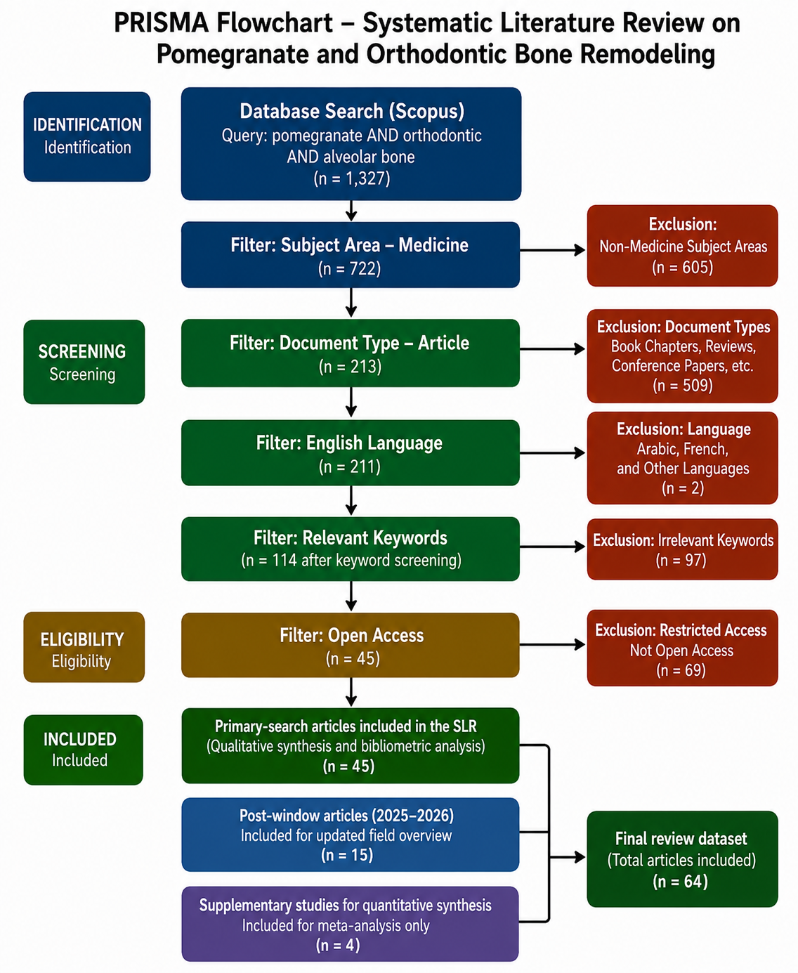
Figure 1: PRISMA 2020 flowchart illustrating the systematic literature search and selection process. The primary Scopus search identified 1,327 initial records published between 2016 and 2024, which were sequentially filtered by subject area, document type, language, keyword relevance, and open-access availability, yielding 45 articles from the primary search window. An additional 15 post-window articles published in 2025–2026 were captured at the June 2026 search date, and 4 supplementary studies were included for quantitative synthesis only. The final review dataset therefore comprised 64 articles.

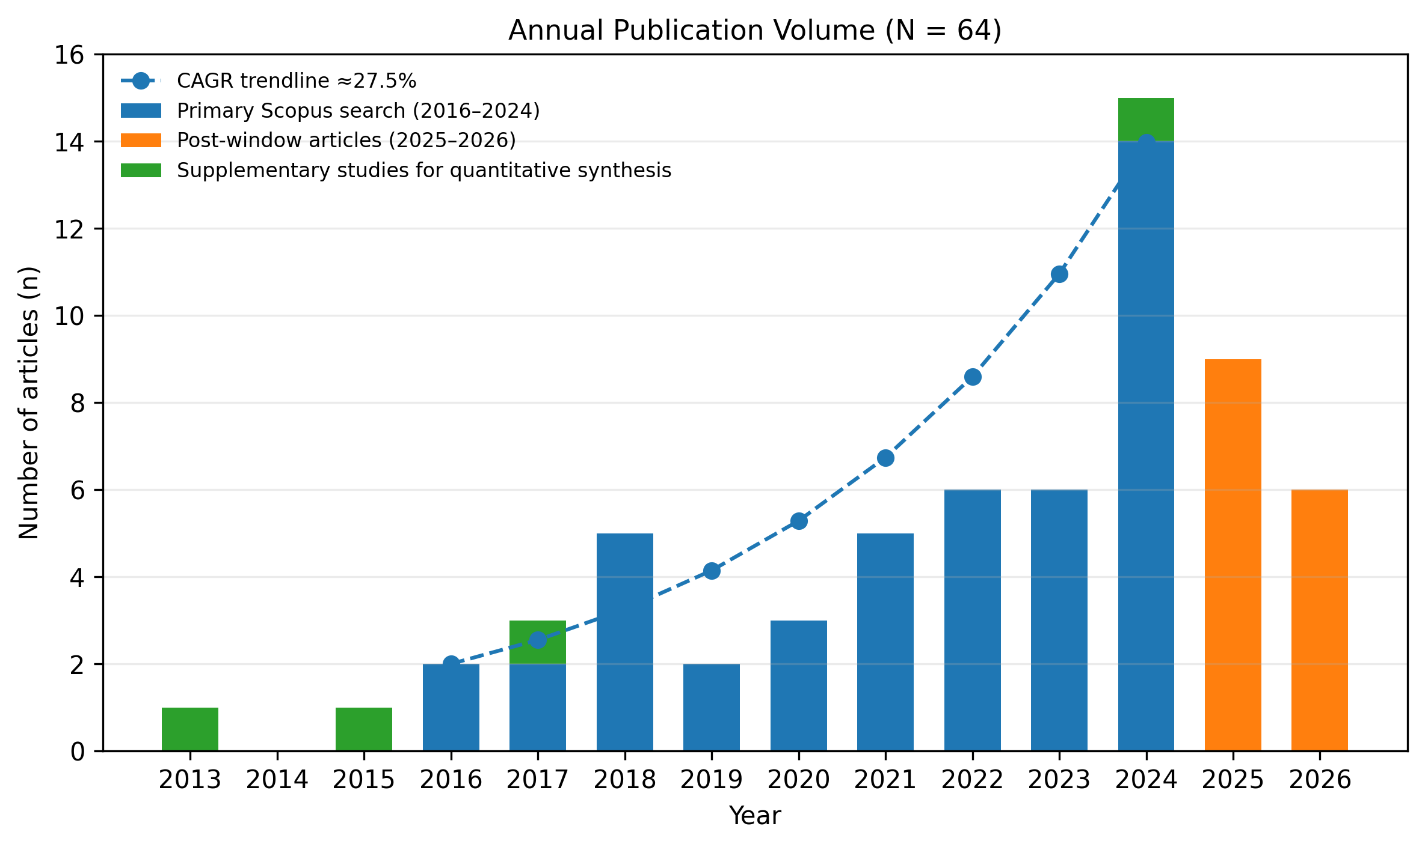
Figure 2: Annual publication volume of articles included in this systematic review (N=64), 2013–2026. Blue bars = primary Scopus search (2016–2024, n=45 articles); green bars = post-search-window articles captured at search date (June 2026, n=15); orange bars = supplementary studies included for quantitative synthesis only (n=4: Spilmont et al., 2013; Spilmont et al., 2015; Kang et al., 2017; Dong et al., 2024). The dashed trendline represents the exponential growth trajectory (CAGR ≈27.5%, calculated for 2016–2024). Note: 2026 data are partial (search cutoff: June 2026). CAGR = compound annual growth rate

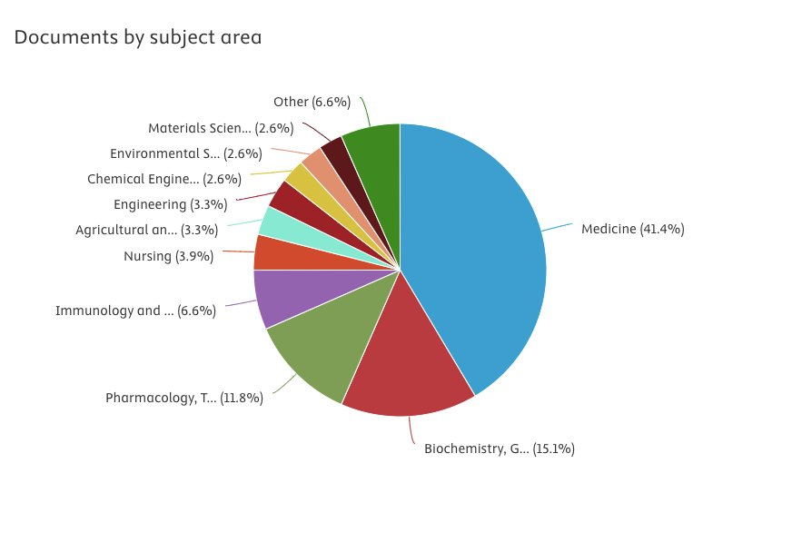
Figure 3: Distribution of the 1,327 initial Scopus records by subject area prior to filtering (Scopus Analytics, June 2026). Medicine dominates the corpus (41.4%), followed by Biochemistry, Genetics and Molecular Biology (15.1%) and Pharmacology, Toxicology and Pharmaceutics (11.8%). The three leading biomedical domains collectively account for 68.3% of records, confirming the biomedical relevance of the search query and justifying the Medicine subject area filter applied at Stage 2 of the selection process.
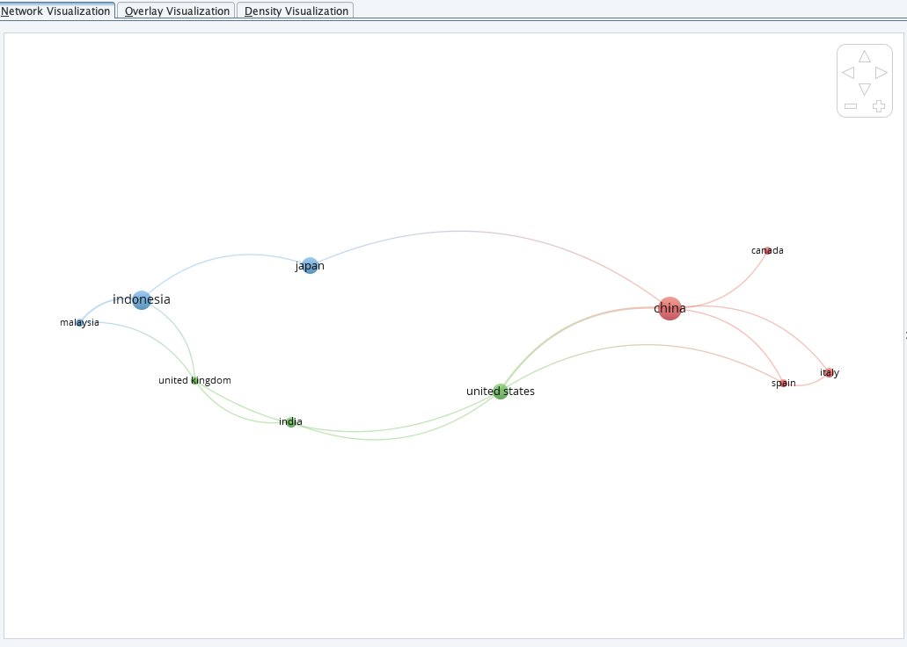
Figure 4: VOSviewer country co-authorship network of the 64 included articles (minimum: 1 document per country; n=10 countries). Node size reflects the number of publications per country; link thickness indicates co-authorship frequency. Three clusters are identified: blue (Southeast Asia: Indonesia, Japan, Malaysia), red (East Asia/Europe: China, Italy, Spain, Canada), and green (North America/South Asia: United States, India, United Kingdom). Indonesia (blue, largest node) and China (red, largest node) are the two dominant research hubs in this domain

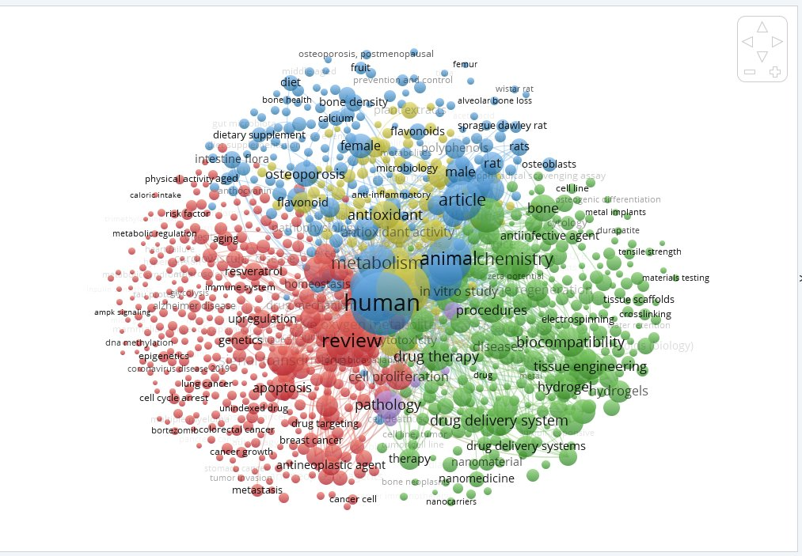
Figure 5. VOSviewer keyword co-occurrence network derived from all 1,327 initial Scopus records (pre-screening; minimum keyword occurrence ≥2; n = 312 keywords, 4 clusters). Node size = keyword occurrence frequency; link thickness = co-occurrence strength. Cluster 1 (red) = bone cell biology and RANKL/OPG signaling; Cluster 2 (green) = oxidative stress and antioxidant pathways; Cluster 3 (blue) = clinical/pharmaceutical and orthodontic context; Cluster 4 (yellow) = natural compound pharmacology. Note: 'orthodontic tooth movement' and 'relapse' occupy peripheral positions relative to pomegranate-specific keywords, providing bibliometric confirmation of the primary research gap identified in this review.

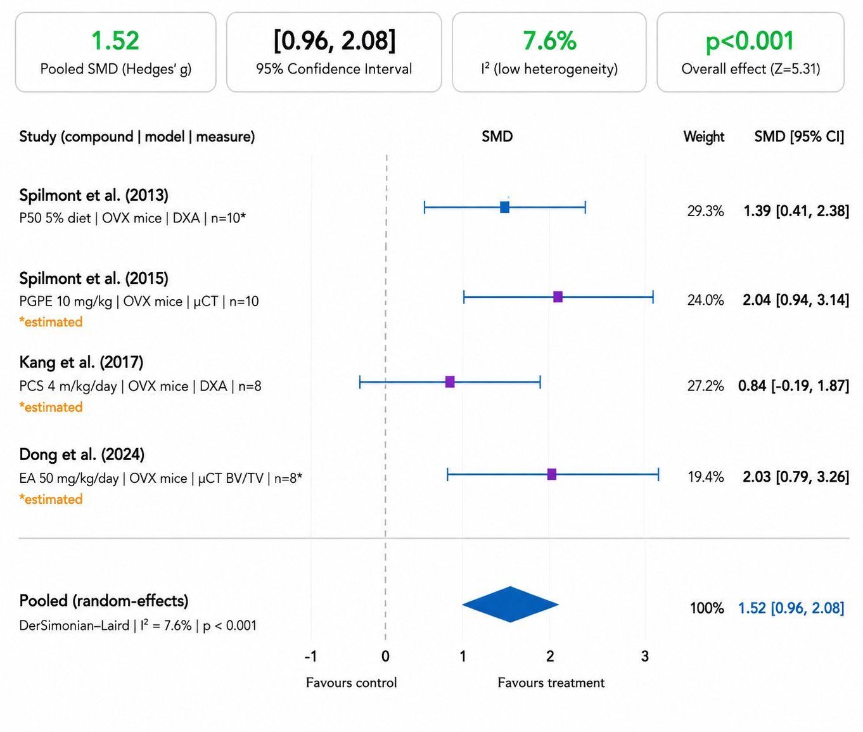
Figure 6. Forest plot of the pooled standardized mean difference (SMD; Hedges’ g) for bone mineral density (BMD) and bone volume outcomes from studies examining pomegranate-derived polyphenols versus ovariectomized (OVX) control animals (n = 4 studies). Squares represent individual study effect estimates, with square size proportional to study weight; horizontal lines represent 95% confidence intervals. The diamond represents the pooled random-effects estimate using the DerSimonian–Laird method: SMD = 1.52, 95% CI [0.96, 2.08], I² = 7.6%, p < 0.001. A positive SMD indicates greater bone density or bone volume in the polyphenol-treated group compared with OVX controls. The pooled estimate should be interpreted cautiously because only four studies were eligible for quantitative synthesis and outcome measurement methods varied across studies. Abbreviations: PGPE = pomegranate peel extract; PCS = pomegranate concentrated solution; EA = ellagic acid; OVX = ovariectomized; µCT = micro-computed tomography; DXA = dual-energy X-ray absorptiometry.

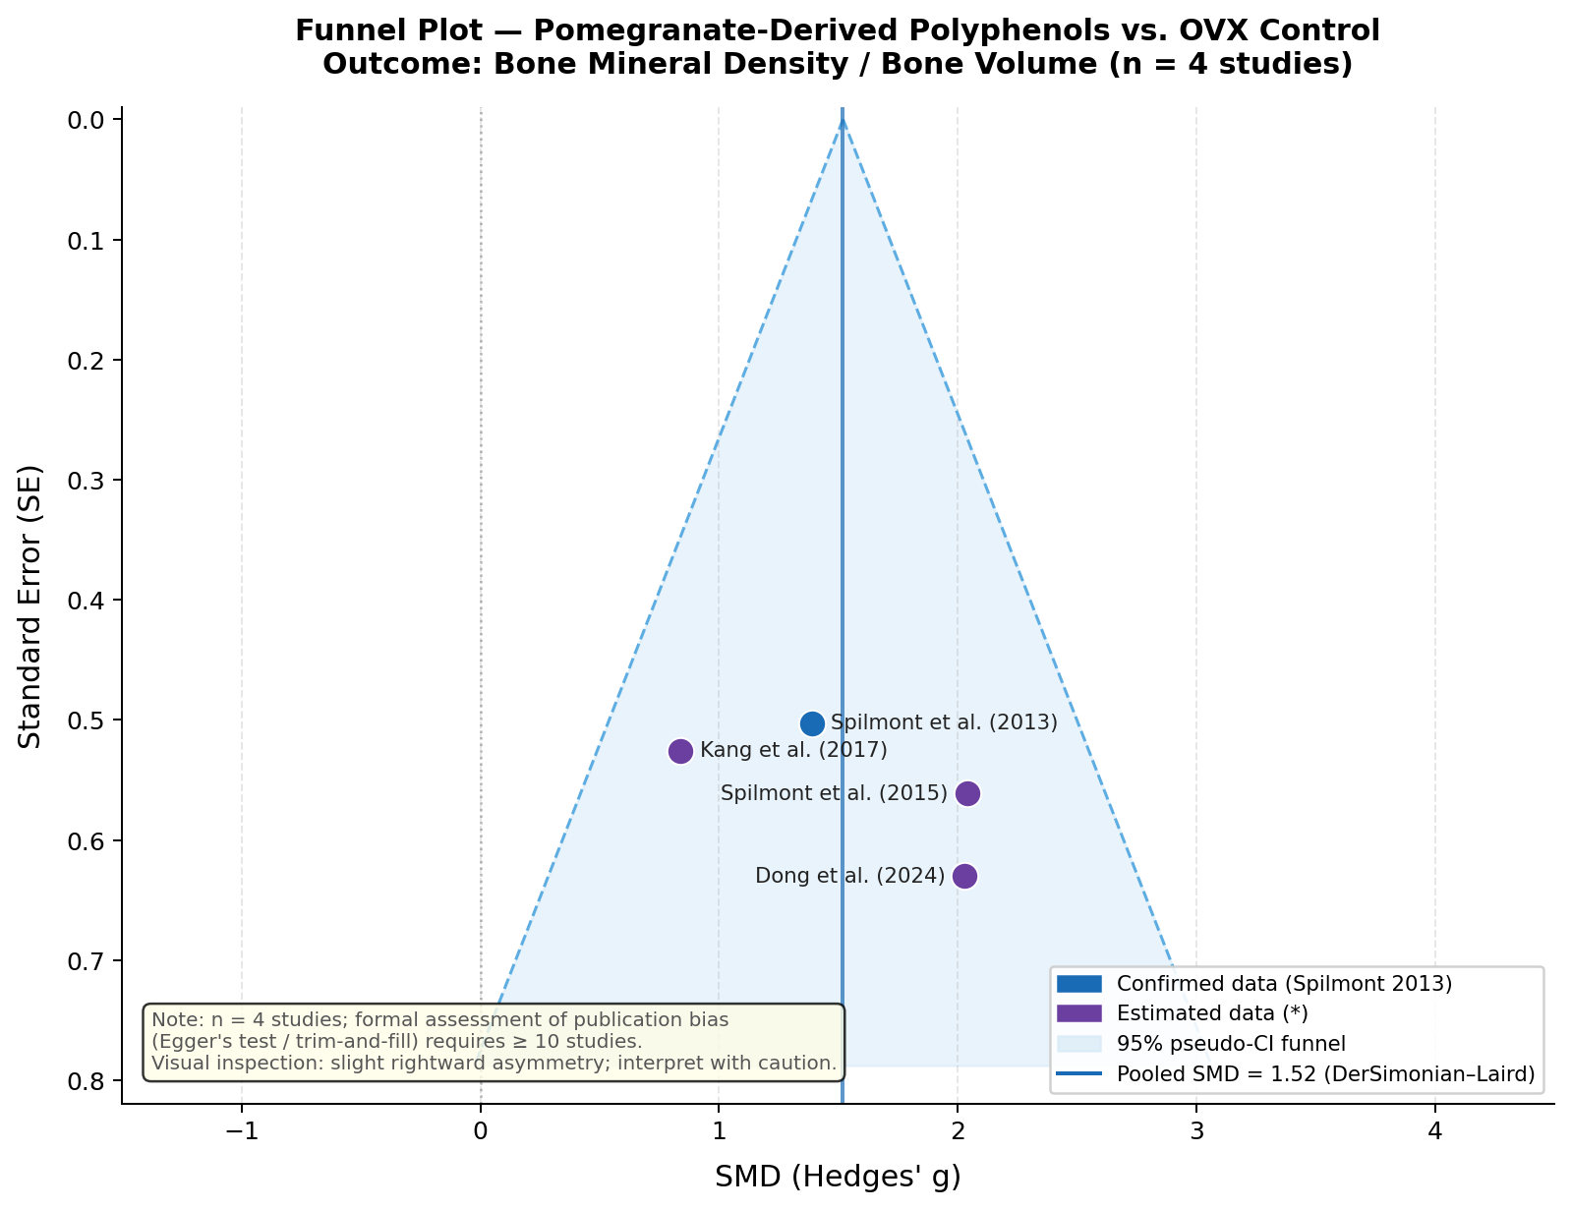
Figure 7. Funnel plot of standard error (SE) against standardized mean difference (SMD; Hedges’ g) for the four studies included in the BMD and bone volume meta-analysis. The dashed lines demarcate the 95% pseudo-confidence interval funnel centered on the pooled SMD (1.52; vertical solid line). Each circle represents one included study. A slight rightward asymmetry is visually apparent, which may reflect small-study effects, variation in compound type and dose, or genuine methodological heterogeneity. Formal statistical assessment of publication bias, including Egger’s test or trim-and-fill analysis, was not performed because fewer than 10 studies were available; therefore, visual inspection is provided only as a qualitative indicator. Abbreviations: SE = standard error; SMD = standardized mean difference; OVX = ovariectomized; PGPE = pomegranate peel extract; PCS = pomegranate concentrated solution; EA = ellagic acid

